Virtual Care Assistant (VCA) Group Project

MOCK UPS/PROTOTYPES:

I have designed the following mock ups to illustrate the graphical user interface for the Virtual Care Assistant Application. The start page is the first screen that will appear on the application. The first screen has icons which are used to access the main functions of the application. These are labelled Audio Features, Home Features, Services and Miscellaneous. Audio Features opens a new screen giving access to Home assistant feature: Tell the current time, Tell the current weather conditions and Play Music.

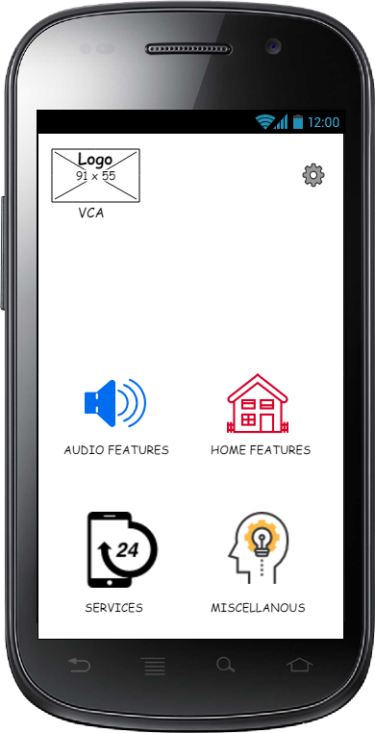 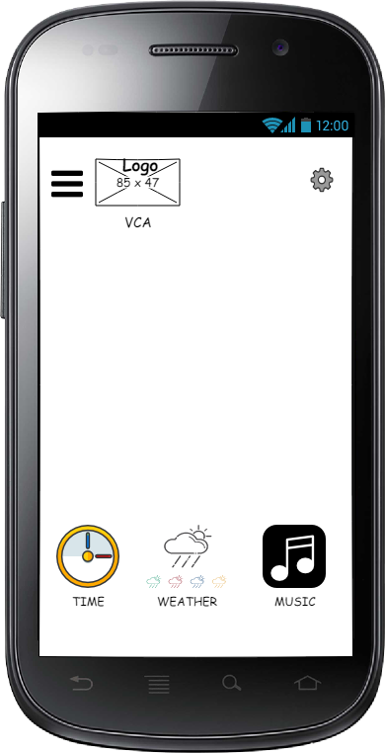

The Home Features Icon on the start screen gives access to Home automation features: Switch lights on/off, Switch heating on/off and Remote Camera.

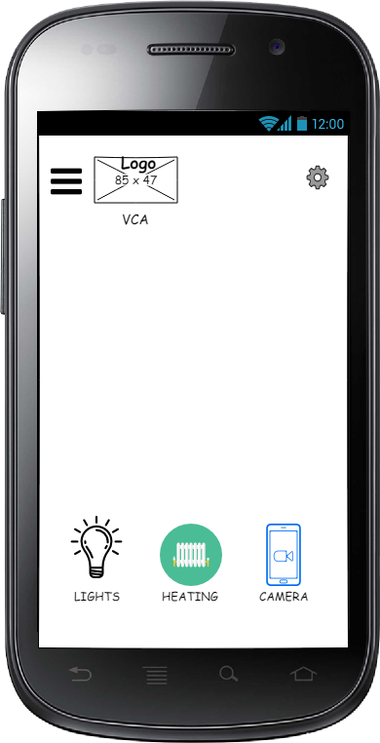

The Services Icon on the start screen gives access to Interactive service features: Order Take away, Order Shopping and Order Taxi.

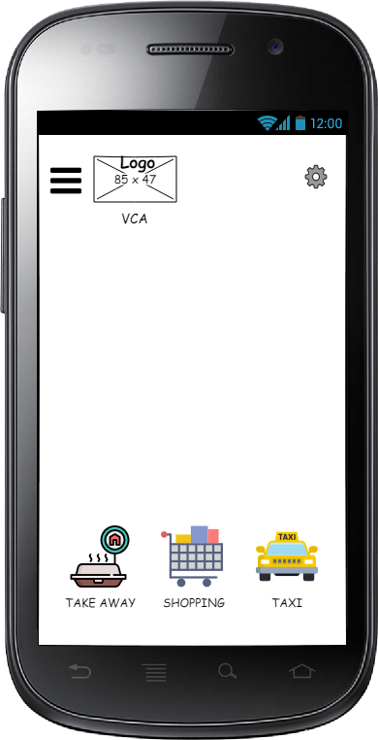

Lastly, the Miscellaneous Screen gives access to Medical features: Multi-level memory game and Calendar functions (record and playback of calendar events).

